**ELED 4872 Assessment Project Explanation**

**Assessment Project:** The purpose of this project is, first and foremost, to help teacher candidates develop skill in assessing elementary students’ learning. Candidates will complete parts of the *TPA Task #3: Assessing Student Learning* component. (This edTPA task will be required in its entirety for Residency II, so a second purpose of this assignment is to introduce candidates to the task.)

Step 1: (To be completed before meeting with the mentoring teacher) Candidates should first read Task 3: Assessing Students’ Learning in the most current edTPA Handbook for the chosen subject area and grade level.

Step 2: After becoming familiar with Task 3 in the appropriate edTPA handbook, candidates should then meet with their Residency I mentoring teacher to discuss an upcoming lesson (which will later be observed by the candidate). During this meeting, the candidate and the mentoring teacher should discuss the following:

* What are the specific standards that will be taught during the lesson?
* What are the specific learning objectives you expect your students to master?
* What evaluation criteria (refer to edTPA Handbook) will you use to analyze student learning? (What should your students be able to do to demonstrate mastery of the objective(s)?)

Step 3: Coordinate with your mentoring teacher to come and observe the lesson. Explain to the mentoring teacher that you will be focusing on the assessment related to the lesson. Keep in mind that assessment does not equal grading!

Step 4: During the lesson, analyze the types of assessment used and take notes of what the teacher and students do. Consider these questions:

* What questions does the teacher ask?
* What questions or responses do the students provide to demonstrate understanding?
* How does the teacher use assessment to guide his/her instruction based on students’ responses and actions during the lesson?
* What verbal and/or written feedback does the teacher provide to the students during the lesson?

Step 5: Selection of Work Samples

* Collect student work from your entire class and analyze student performance to identify patterns in understanding within the class. Keep all students’ names anonymous.
* Select 3 student work samples representing what students in your class generally understood from the lesson and what a number of students were still struggling to understand. At least one of the students must have been identified as having learning needs, such as an English language learner or a student with an IEP. (Suggestion…struggling, partial or basic, and exceptional)
* What specific evidence was demonstrated by each of the three focus students to show their level of mastery?
* Based on the chosen students’ work samples and performance, what verbal feedback would you provide to each student? What written feedback would you provide for each student? Include specific evidence.
* Explain how the feedback provided to the 3 focus students addresses their individual strengths and needs relative to the standards/objectives measured.

Step 6: Using Assessment to Inform Future Instruction

Explain how you could use the evidence gathered to inform your upcoming instruction with the class and the three focus students.

COMPLETE THE FOLLOWING TEMPLATE AND SUBMIT BY THE DUE DATE. ONLY INCLUDE THE INFORMATION THAT FOLLOWS WHEN SUBMITTING YOUR ASSIGNMENT.

(**Source: ed*TPA Elementary Education Assessment Handbook, 2013*)**

**ELED 4872 Assessment Project Template**

TTU Candidate’s Name: Haylee Layman

Mentoring Teacher’s Name, Grade, and School: LaTisha Grayson, 2nd Grade, Whitwell Elementary School

Date of Pre-Conference with Mentor: Friday, September 27, 2013

Date of Lesson Observation: Friday, October 4, 2013

Time of Lesson Observation: (from 9:20 to 11:10)

Complete the template below by typing in the white area. Use as much space as needed to provide thorough evidence.

|  |  |  |  |
| --- | --- | --- | --- |
| Pre-Conference with Mentoring Teacher | | | |
| What specific standards will be taught during the lesson? | RF.2.4- I can read with expression and self-correct words.  L.2.1- I can find the pronoun in the sentence.  W.2.3- I can write a narrative to describe events.  RL.2.3- I can describe how characters respond to challenges.  SL.2.3- I can talk to my peers and ask questions.  L.2.2- I can use an apostrophe to form a contraction. | | |
| What learning objectives should students master? | TSW:  Read with expression  Self-correct while reading  Write a narrative to describe events  Describe how characters respond to challenges  Ask questions  Link prior knowledge to current material  Use contractions: n’t, ‘m, ‘s,’ll | | |
| What evaluation criteria (refer to edTPA Handbook) will be used to analyze student learning? | Second Grade TN Common Core Standards are used to show what is being taught during this lesson.  Objectives are used to demonstrate what requisite skills the student should be able to show mastery on as a result of the lesson.  Fluency Data is used to demonstrate the students’ growth and mastery levels from previous lessons through this lesson.  Assessments are used to show whether the student received non-mastery, partial mastery, or mastery of the objectives covered in this lesson. The Assessments demonstrate the essential literacy strategy as well as the requisite skills covered in this week’s lesson topics.  Pacing Plan is used to show what standards and objectives are covered with this lesson and the weekly skills that the students should be able to master as a result of the lesson. | | |
| Observation of Lesson | | | |
| What questions does the teacher ask? | Who are we talking about?  Who knows what “genre” is?  What is informational text?  What is an author?  What does the illustrator do?  What does it mean when people work together to change the world?  You will be writing a narrative, who can tell me what a narrative is?  Who is Abraham Lincoln? How can you tell it’s who he is?  Point to the contraction on the page. What is it? What two words make I’ll?  What kind of noun is Abraham Lincoln?  Why is he a proper noun?  What do the quotation marks mean?  What does an exclamatory sentence end with?  How should we read he sentence with exclamation mark at the end?  Why was Abe Lincoln’s life hard?  What are they trying to show you at the bottom with the photo of the classroom and the drawing of the classroom?  What is a verb?  Give me some examples of verbs on this page.  Why do people admire Abraham Lincoln?  What is Abraham Lincoln’s big problem?  What did they do to put the country back together? | | |
| What questions or responses do the students ask to demonstrate understanding? | Abraham Lincoln.  He was shot in the back of the head.  Informational Text- gives us information about what we’re reading.  The author writes the story.  They draw and color the pictures.  Trying to get the world back together the way it was before.  Put it together like the Lorax did in that one movie, when he made the world a perfect place to live.  It’s a story that we’re going to write.  He was the president of our country, the USA.  Because he is wearing a suit and he has a hat and a beard. He looks the most important from all the other people on the page.  What is a contraction?  I’ll is made from I and will.  There’s also another contraction on the page, it’s didn’t, and that means did not.  Proper Noun!  He’s a person!  Those mean that people are talking.  A student reads a sentence with an exclamation mark, using excitement as she reads.  1809 was two centuries ago! That’s a LONG time ago!  He chopped wood to make fences.  He didn’t have any toys or games.  There was no air conditioner at his house. He probably sweated a whole lot.  They’re there to show the differences in classrooms before and the way they are now.  Run, plow, carried, chopped, planted.  They called him Honest Abe.  He was a hard worker and he was fair to everyone.  Slavery.  He wants to keep the country together.  They worked together to put it back together. | | |
| How does the teacher use assessment to guide his/her instruction based on the students’ responses and actions during the lesson? | Mrs. Tish uses formative assessments to guide her instruction. When the students show understanding, she makes the instruction more advanced to challenge the students to think harder. She asks questions that are explicitly related to the material that is being covered, and uses information she gathers from the guided practice and centers to help her give feedback on what the students are doing well and how they can still improve. She also uses the guided practice and centers as a way to give her feedback on what SHE needs to do to better accommodate her students’ needs in the classroom. She asks questions and documents their answers, and makes notes of what they understand as well as what they do not. She then makes a plan that will help her students through differentiated material and more guided practice. | | |
| What verbal and/or written feedback does the teacher provide to the students during the lesson? | Tish goes more into detail when discussing the students’ questions and answers. She uses encouraging comments to get the kids to think harder and ask more questions. As she walks around the classroom, she will see if several students are missing the same problem. If she witnesses this, she goes to the front of the classroom and says, “Let’s look at this together.” She then goes through the steps they need to better understand the problems. She restates the questions the students ask so that everyone can hear and then gives them detailed information on the questions.  Some examples of the verbal feedback used during this lesson:  This looks great!  You’re getting there, let’s look at this part…  Thanks for bringing that up, let’s backtrack and go through the steps.  That’s a good question; let’s take a look at it.  A lot of you are not getting this, let’s do it together. | | |
| What other relevant information did you observe? For example, in what activities are the students engaged in to demonstrate mastery? | →I observed Centers that are explicit to the current common core state standards as well as the current lesson that are used for more independent practices.  Writing Center- The students find contractions around the room and write them as well as the two words that make up the contractions on a chart provided in the writing center. (Example: won’t=will not)  Contraction add-it-up-The students add up their spelling words. Consonants=10 points, vowels= 5 points. (Example: I’ll= 25)  Listening centers-The students must listen to the story two times. Then they must write a narrative about what went on in the story as well as what problems the characters faced during the story.  Guided reading-The students read to Mrs. Tish.  **As I walked around observing the centers, I kept a chart and kept up with each student whether they were getting the material, some what understand, or do not understand at all. (The chart is attached)  →I also observed student worksheets that go along with the requisite skills for this week from identifying pronouns as well as using contractions. | | |
| Following the Lesson | | | |
| Analyze student work from the entire class. What patterns of understanding do you notice as a class, overall? | Overall, the majority of the class appears to grasp the material that is being covered in this week’s lesson. To enhance oral language, The teacher asked several questions to the students about the story and provided several opportunities for the students to share their thinking and learning with the rest of the class (S.L.2.3). The class as a whole demonstrates strong understanding of contractions; all students scored mastery on this skill even the lower performing students (L.2.2). The majority of the students mastered the reading with expression skill, and they demonstrate an explicit understanding of the punctuation. This skill is represented with the reading of the weekly fluency story (RF.2.4). The majority of the class demonstrates mastery of Proper nouns. They can tell what a proper noun is, and that they need to be capitalized (L.2.1). 4/23 students scored Partial Mastery on their tests, while 19/23 scored Mastery. | | |
| 3 Focus Students | Student 1  (Struggling to master) | Student 2  (Partial to basic mastery) | Student 3  (Complete mastery) |
| Select three student work samples which demonstrate varying mastery levels (struggling, partial or basic, and complete). Describe each student’s level of mastery using specific evidence. | **-Fluency** – Student struggles to meet mastery in fluency. Mastery is defined as reading 60 words per minute. He has maxed out at 33 words within the minute with eight errors.  -**Language Arts Test**- Partial Mastery. Student has trouble identifying pronouns as well as capitalization of the pronouns.  **-Vocabulary**- Mastery. Student did very well with choosing the correct word to complete each sentence.  **-Phonics-** Mastery. Student does very well with understanding what two words make up contractions, as well as placing the apostrophe in the correct place.  **Reading/Comprehension-** Non Mastery. Student did not follow directions. He has difficulty with linking the questions back to the text as well as going back to the text to underline the answers to the questions. | **-Fluency-** Student demonstrates Partial Mastery with fluency. This week, she maxed out at 55 words within the minute with zero errors.  -**Language Arts Test-** Mastery. Student demonstrates clear understanding of pronouns and correct capitalization of the pronouns.  **-Vocabulary-** Mastery. Student did very well with choosing the correct word to complete each sentence.  **-Phonics**-Mastery. Student does very well with understanding what two words make up contractions, as well as placing the apostrophe in the correct place.  **Reading/Comprehension-**Partial Mastery. Student shows difficulty in synthesizing information to link the questions back to the story to answer the questions. | **-Fluency-** Student demonstrates complete Mastery. This week, he maxed out at 145 words within the minute with 0 errors.  -**Language Arts-** Mastery. Student demonstrates a clear understanding of pronouns and correct capitalization of the pronouns.  **-Vocabulary**-Mastery. Student did very well with choosing the correct word to complete each sentence.  **-Phonics-** Mastery. Student does very well with understanding what two words make up the contractions, as well as placing the apostrophe in the correct place.  **Reading/Comprehension**  Mastery. Student knows to synthesize information in the text to find the answers to the questions. He underlines the answers to the questions to provide evidence of understanding the questions. |
| Based on the lesson observation and the work samples, what specific written and/or verbal feedback would you provide for each of these students? | **Language Test**  -Only capitalize the first letter of the month. “October”  -You must include the whole name for full credit.  -The subject tells what the sentence is about.  **Vocabulary**  -Awesome! Great job! ☺  **Phonics**  -Great! ☺  **Reading/Comprehension**  -Underline the answers in the story.  -Remember to ALWAYS go back to the story and underline the answers.  (attached) | **Language Test-**  -Remember to always capitalize the name of the month, it is a proper noun.  -The subject tells what the sentence is about.  **Vocabulary**  -Great job! ☺  **Phonics**  -Good!  **Reading/Comprehension**  -Remember to go back to the story and underline the answers to the questions. | **Language**  -Remember names are always capitalized.  -Great job!  **Vocabulary**  -Awesome! ☺  **Phonics**  -Great job! ☺  **Reading/Comprehension**  -Great! ☺ |
| Explain how the feedback provided to the three focus students addresses their individual strengths and needs relative to the standards/objectives measured. | The feedback given to Student 1 provides the student with the things he did correctly, as well as specific things he missed. This will help guide him to know what to do on future tests and help him reach mastery level on the upcoming objectives. | The feedback provided for Student 2 provides her with the things she did correctly, as well as specific details on the things she missed. By providing such feedback, the student will have guidance on what to do in order to reach mastery on the upcoming objectives. | Out of all the assessments, Student 3 only missed one part of the problem. He forgot to capitalize a name. The feedback provided for Student 3 reminds him to always capitalize names of people. This feedback will help him stay on the track of mastery. |
| Using the assessment evidence, what future instruction would you plan for each student? | The evidence from this assessment would provide me with the information that I would need in order to make modifications to future assessments. For this student I would give extra help with capitalization rules with proper nouns as well as the difference between a subject and predicate is. I would remind the students of the importance of going back to the text to find the answers of the questions. I would focus on the intricate details of the objectives to better help this student to score mastery on upcoming objectives. | The evidence from this assessment would provide me with the information that I would need in order to make modifications to future assessments. The evidence from this assessment shows that Student 2 has difficulty understanding the capitalization rules as well as knowing the difference between the subject and predicate of a sentence. I would also remind the student to always return to the story to find answers to the questions. Based on this information, I would focus on intricate details of the objectives, to better assist this student on receiving mastery on the upcoming objectives. | Even though student 3 has scored only one point away from a perfect mastery, this student still has difficulty with capitalization. For this student I would remind him of the capitalization rules. By doing this, Student 3 will have a better chance at scoring a perfect 100 on future assessments. |

Information has been adapted from the *edTPA Elementary Education Assessment Handbook*, January 2013. This assignment and template are being used to introduce the teacher candidates to the edTPA tasks and are not to be used when submitting information to Pearson for grading purposes. Also, the rubric created to evaluate this assignment is for grading purposes for ELED 4872 and is not an indication of the quality of work to be expected from Pearson. When submitting edTPA tasks to Pearson, candidates should refer to the edTPA Handbooks and the rubrics provided in them.

Student 1:Non Mastery

Student 2

Student 3-Mastery

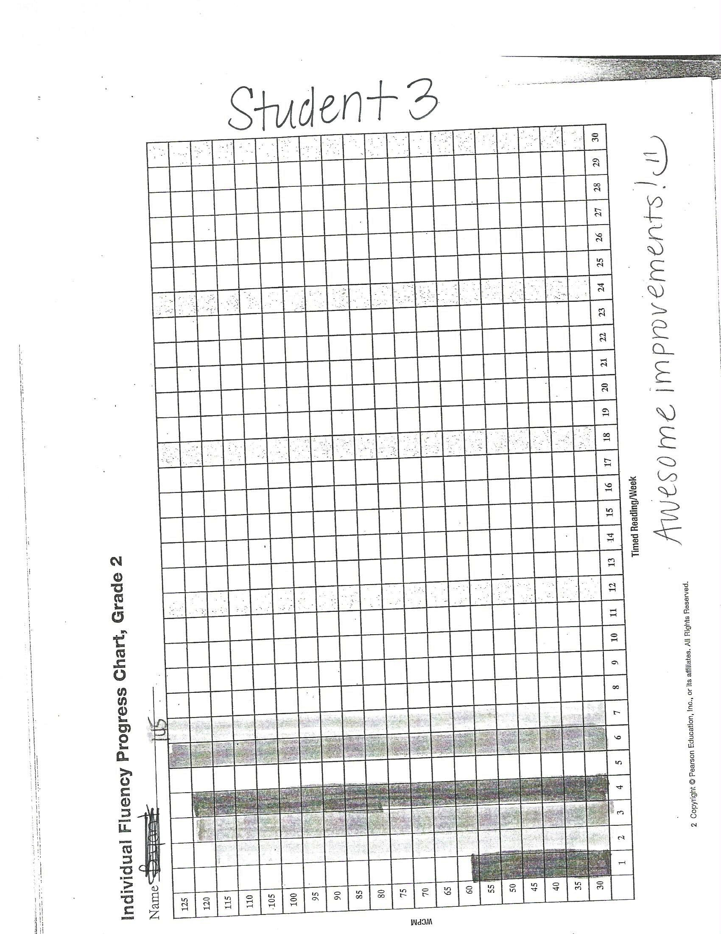

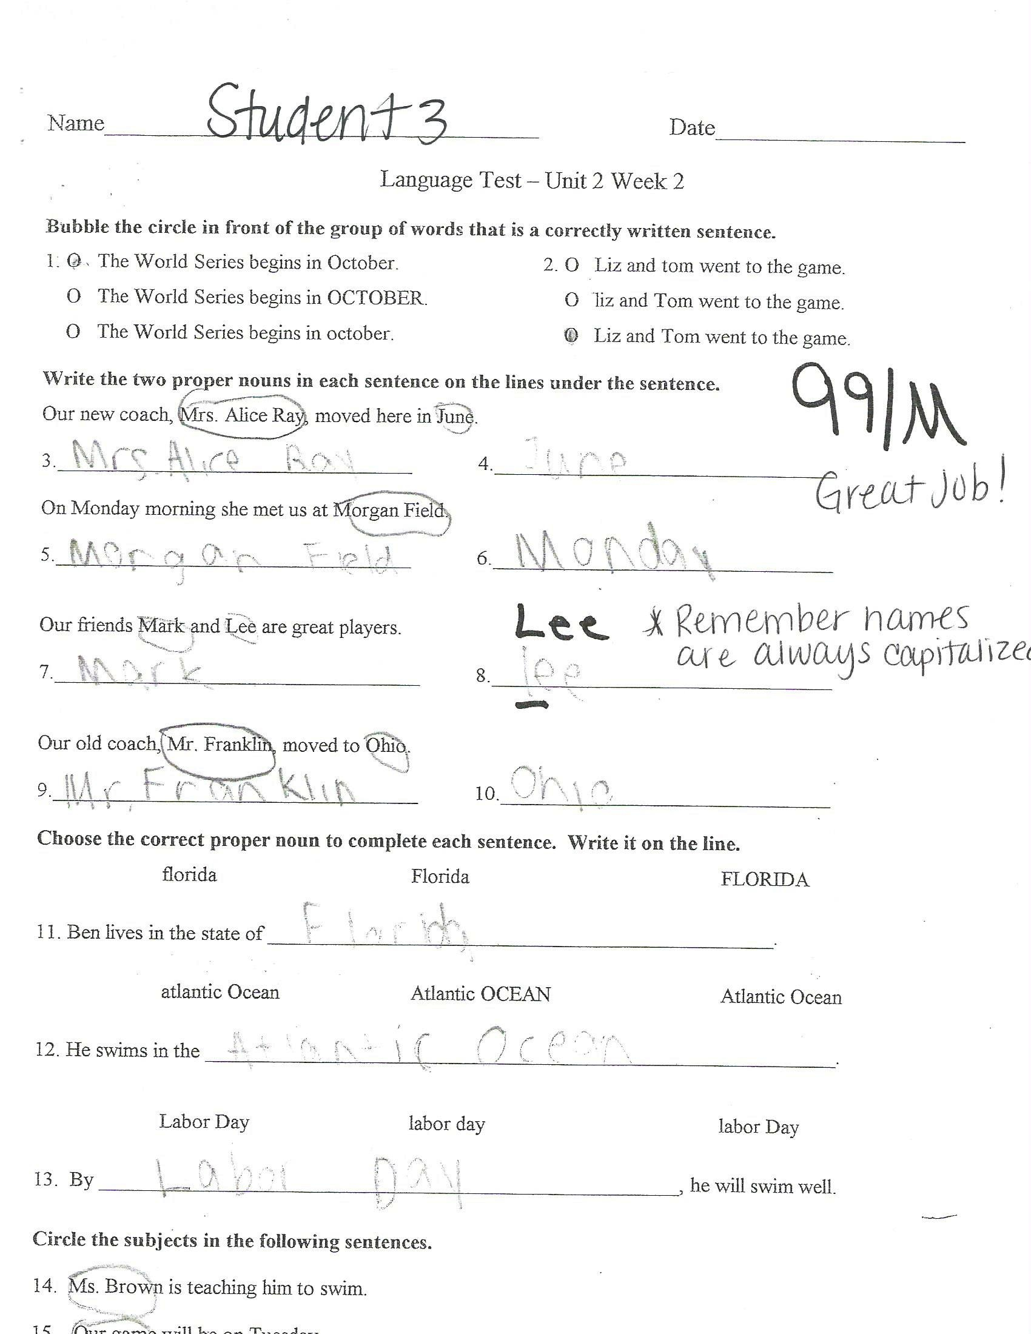

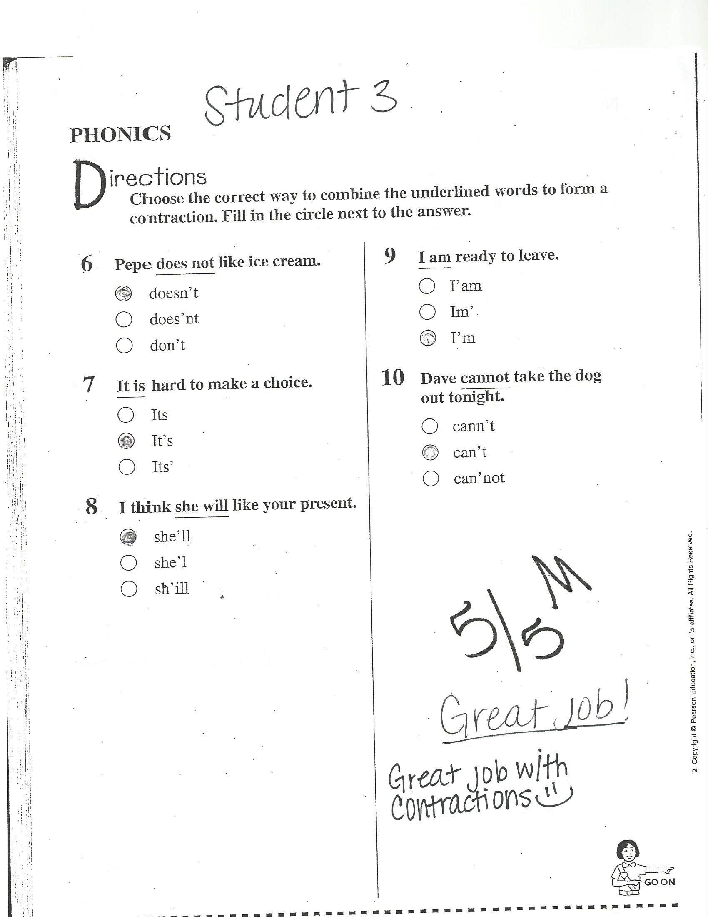

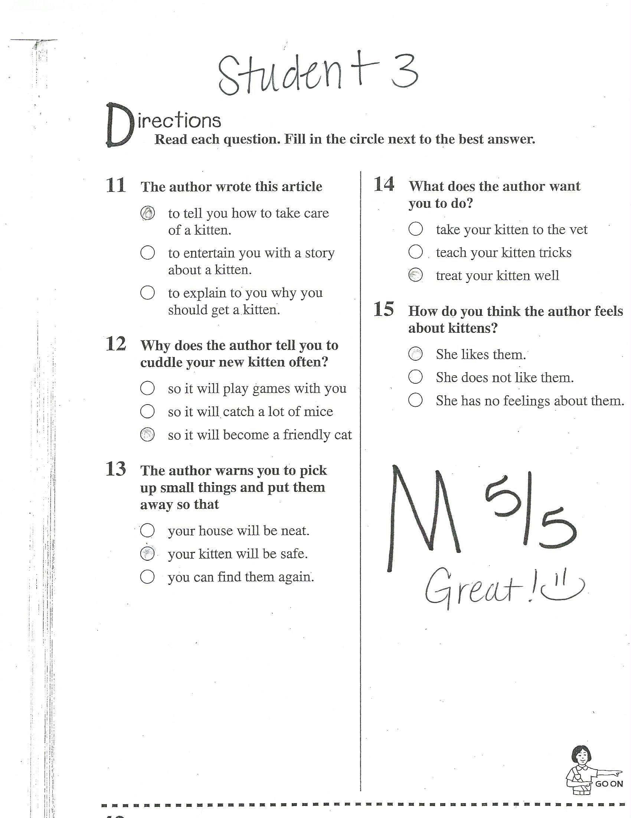

Whole Class Student Test Data

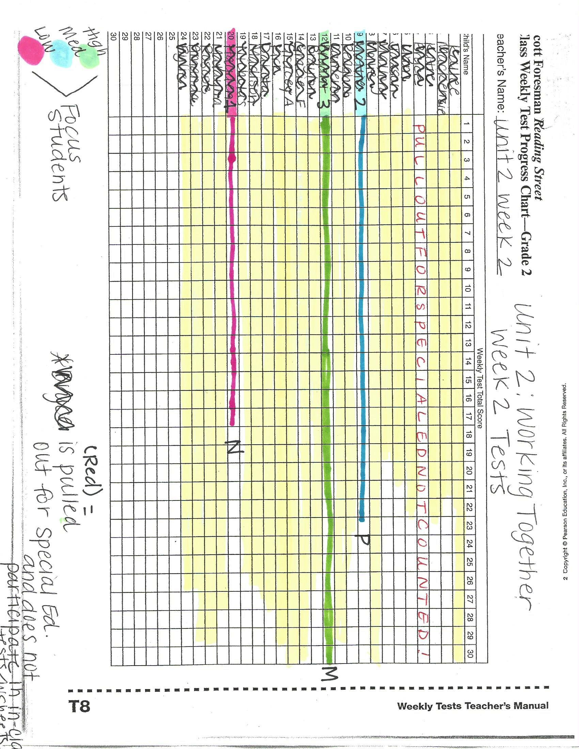

Centers Observation with Feedback

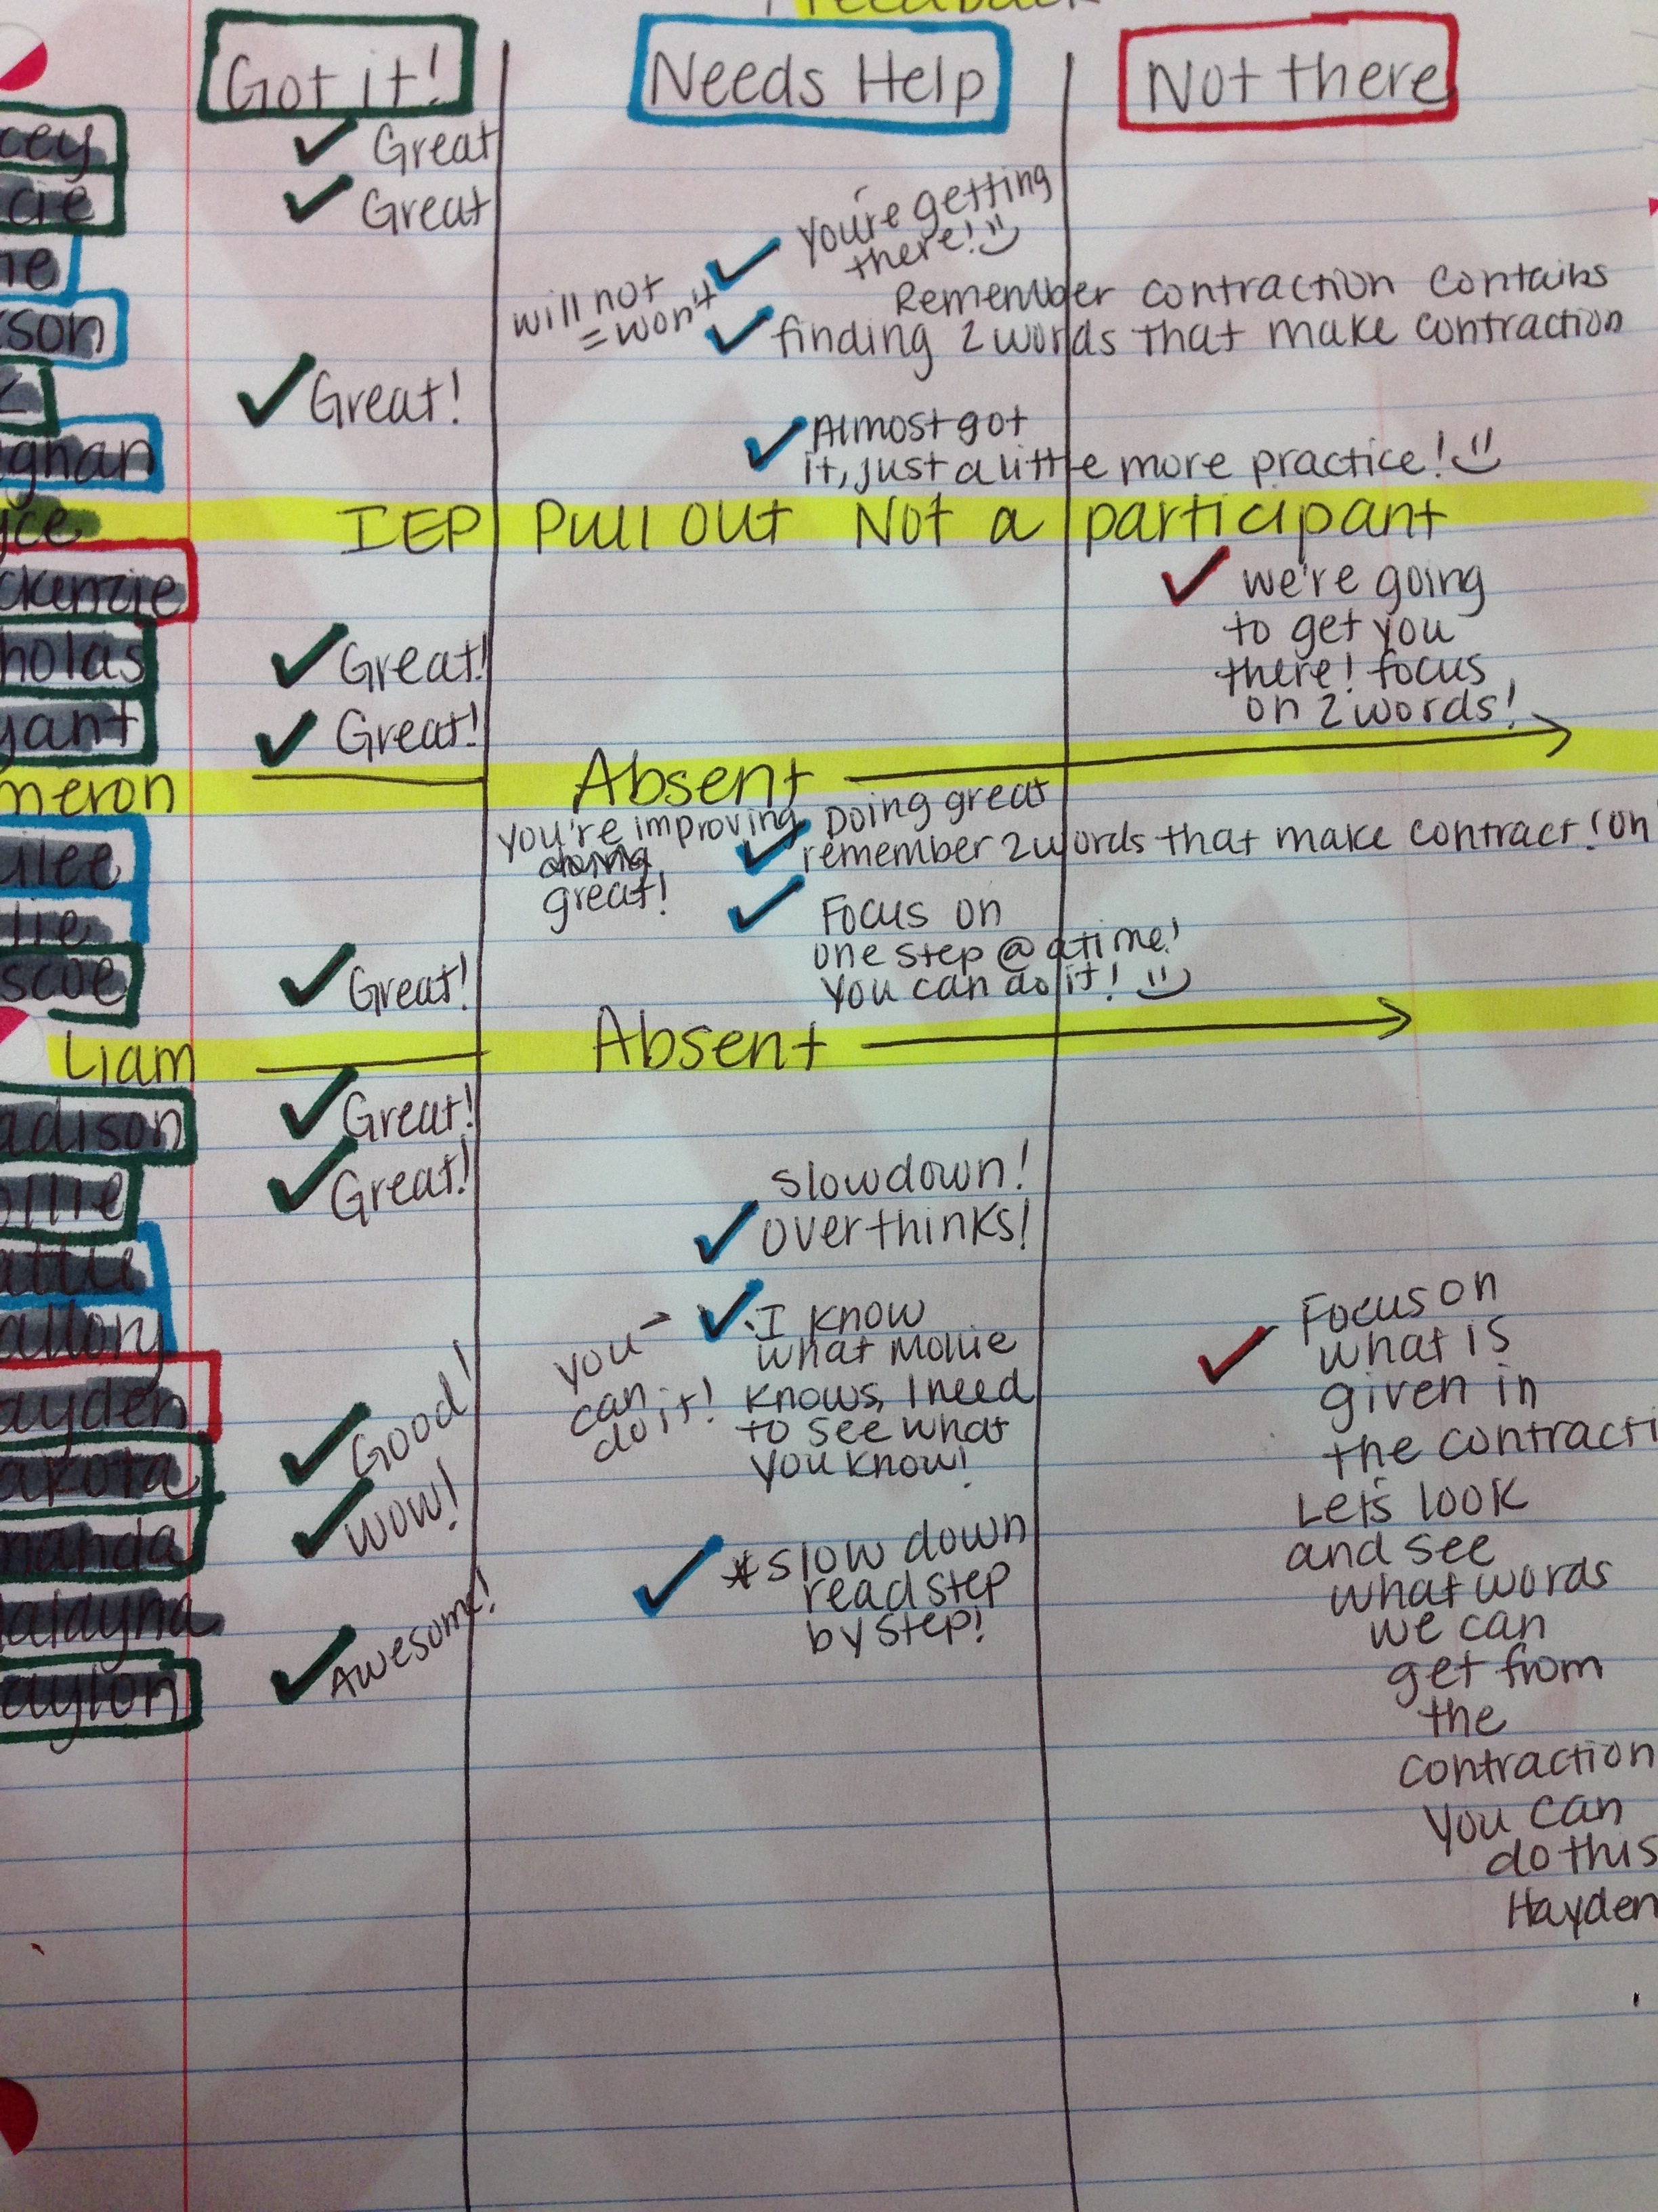

**ELED 4872 Assessment Project Explanation**

**Assessment Project:** The purpose of this project is, first and foremost, to help teacher candidates develop skill in assessing elementary students’ learning. Candidates will complete parts of the *TPA Task #3: Assessing Student Learning* component. (This edTPA task will be required in its entirety for Residency II, so a second purpose of this assignment is to introduce candidates to the task.)

Step 1: (To be completed before meeting with the mentoring teacher) Candidates should first read Task 3: Assessing Students’ Learning in the most current edTPA Handbook for the chosen subject area and grade level.

Step 2: After becoming familiar with Task 3 in the appropriate edTPA handbook, candidates should then meet with their Residency I mentoring teacher to discuss an upcoming lesson (which will later be observed by the candidate). During this meeting, the candidate and the mentoring teacher should discuss the following:

* What are the specific standards that will be taught during the lesson?
* What are the specific learning objectives you expect your students to master?
* What evaluation criteria (refer to edTPA Handbook) will you use to analyze student learning? (What should your students be able to do to demonstrate mastery of the objective(s)?)

Step 3: Coordinate with your mentoring teacher to come and observe the lesson. Explain to the mentoring teacher that you will be focusing on the assessment related to the lesson. Keep in mind that assessment does not equal grading!

Step 4: During the lesson, analyze the types of assessment used and take notes of what the teacher and students do. Consider these questions:

* What questions does the teacher ask?
* What questions or responses do the students provide to demonstrate understanding?
* How does the teacher use assessment to guide his/her instruction based on students’ responses and actions during the lesson?
* What verbal and/or written feedback does the teacher provide to the students during the lesson?

Step 5: Selection of Work Samples

* Collect student work from your entire class and analyze student performance to identify patterns in understanding within the class. Keep all students’ names anonymous.
* Select 3 student work samples representing what students in your class generally understood from the lesson and what a number of students were still struggling to understand. At least one of the students must have been identified as having learning needs, such as an English language learner or a student with an IEP. (Suggestion…struggling, partial or basic, and exceptional)
* What specific evidence was demonstrated by each of the three focus students to show their level of mastery?
* Based on the chosen students’ work samples and performance, what verbal feedback would you provide to each student? What written feedback would you provide for each student? Include specific evidence.
* Explain how the feedback provided to the 3 focus students addresses their individual strengths and needs relative to the standards/objectives measured.

Step 6: Using Assessment to Inform Future Instruction

Explain how you could use the evidence gathered to inform your upcoming instruction with the class and the three focus students.

COMPLETE THE FOLLOWING TEMPLATE AND SUBMIT BY THE DUE DATE. ONLY INCLUDE THE INFORMATION THAT FOLLOWS WHEN SUBMITTING YOUR ASSIGNMENT.

(**Source: ed*TPA Elementary Education Assessment Handbook, 2013*)**

**ELED 4872 Assessment Project Template**

TTU Candidate’s Name: Haylee Layman

Mentoring Teacher’s Name, Grade, and School: LaTisha Grayson, 2nd Grade, Whitwell Elementary School

Date of Pre-Conference with Mentor: Friday, September 27, 2013

Date of Lesson Observation: Friday, October 4, 2013

Time of Lesson Observation: (from 9:20 to 11:10)

Complete the template below by typing in the white area. Use as much space as needed to provide thorough evidence.

|  |  |  |  |
| --- | --- | --- | --- |
| Pre-Conference with Mentoring Teacher | | | |
| What specific standards will be taught during the lesson? | RF.2.4- I can read with expression and self-correct words.  L.2.1- I can find the pronoun in the sentence.  W.2.3- I can write a narrative to describe events.  RL.2.3- I can describe how characters respond to challenges.  SL.2.3- I can talk to my peers and ask questions.  L.2.2- I can use an apostrophe to form a contraction. | | |
| What learning objectives should students master? | TSW:  Read with expression  Self-correct while reading  Write a narrative to describe events  Describe how characters respond to challenges  Ask questions  Link prior knowledge to current material  Use contractions: n’t, ‘m, ‘s,’ll | | |
| What evaluation criteria (refer to edTPA Handbook) will be used to analyze student learning? | Second Grade TN Common Core Standards are used to show what is being taught during this lesson.  Objectives are used to demonstrate what requisite skills the student should be able to show mastery on as a result of the lesson.  Fluency Data is used to demonstrate the students’ growth and mastery levels from previous lessons through this lesson.  Assessments are used to show whether the student received non-mastery, partial mastery, or mastery of the objectives covered in this lesson. The Assessments demonstrate the essential literacy strategy as well as the requisite skills covered in this week’s lesson topics.  Pacing Plan is used to show what standards and objectives are covered with this lesson and the weekly skills that the students should be able to master as a result of the lesson. | | |
| Observation of Lesson | | | |
| What questions does the teacher ask? | Who are we talking about?  Who knows what “genre” is?  What is informational text?  What is an author?  What does the illustrator do?  What does it mean when people work together to change the world?  You will be writing a narrative, who can tell me what a narrative is?  Who is Abraham Lincoln? How can you tell it’s who he is?  Point to the contraction on the page. What is it? What two words make I’ll?  What kind of noun is Abraham Lincoln?  Why is he a proper noun?  What do the quotation marks mean?  What does an exclamatory sentence end with?  How should we read he sentence with exclamation mark at the end?  Why was Abe Lincoln’s life hard?  What are they trying to show you at the bottom with the photo of the classroom and the drawing of the classroom?  What is a verb?  Give me some examples of verbs on this page.  Why do people admire Abraham Lincoln?  What is Abraham Lincoln’s big problem?  What did they do to put the country back together? | | |
| What questions or responses do the students ask to demonstrate understanding? | Abraham Lincoln.  He was shot in the back of the head.  Informational Text- gives us information about what we’re reading.  The author writes the story.  They draw and color the pictures.  Trying to get the world back together the way it was before.  Put it together like the Lorax did in that one movie, when he made the world a perfect place to live.  It’s a story that we’re going to write.  He was the president of our country, the USA.  Because he is wearing a suit and he has a hat and a beard. He looks the most important from all the other people on the page.  What is a contraction?  I’ll is made from I and will.  There’s also another contraction on the page, it’s didn’t, and that means did not.  Proper Noun!  He’s a person!  Those mean that people are talking.  A student reads a sentence with an exclamation mark, using excitement as she reads.  1809 was two centuries ago! That’s a LONG time ago!  He chopped wood to make fences.  He didn’t have any toys or games.  There was no air conditioner at his house. He probably sweated a whole lot.  They’re there to show the differences in classrooms before and the way they are now.  Run, plow, carried, chopped, planted.  They called him Honest Abe.  He was a hard worker and he was fair to everyone.  Slavery.  He wants to keep the country together.  They worked together to put it back together. | | |
| How does the teacher use assessment to guide his/her instruction based on the students’ responses and actions during the lesson? | Mrs. Tish uses formative assessments to guide her instruction. When the students show understanding, she makes the instruction more advanced to challenge the students to think harder. She asks questions that are explicitly related to the material that is being covered, and uses information she gathers from the guided practice and centers to help her give feedback on what the students are doing well and how they can still improve. She also uses the guided practice and centers as a way to give her feedback on what SHE needs to do to better accommodate her students’ needs in the classroom. She asks questions and documents their answers, and makes notes of what they understand as well as what they do not. She then makes a plan that will help her students through differentiated material and more guided practice. | | |
| What verbal and/or written feedback does the teacher provide to the students during the lesson? | Tish goes more into detail when discussing the students’ questions and answers. She uses encouraging comments to get the kids to think harder and ask more questions. As she walks around the classroom, she will see if several students are missing the same problem. If she witnesses this, she goes to the front of the classroom and says, “Let’s look at this together.” She then goes through the steps they need to better understand the problems. She restates the questions the students ask so that everyone can hear and then gives them detailed information on the questions.  Some examples of the verbal feedback used during this lesson:  This looks great!  You’re getting there, let’s look at this part…  Thanks for bringing that up, let’s backtrack and go through the steps.  That’s a good question; let’s take a look at it.  A lot of you are not getting this, let’s do it together. | | |
| What other relevant information did you observe? For example, in what activities are the students engaged in to demonstrate mastery? | →I observed Centers that are explicit to the current common core state standards as well as the current lesson that are used for more independent practices.  Writing Center- The students find contractions around the room and write them as well as the two words that make up the contractions on a chart provided in the writing center. (Example: won’t=will not)  Contraction add-it-up-The students add up their spelling words. Consonants=10 points, vowels= 5 points. (Example: I’ll= 25)  Listening centers-The students must listen to the story two times. Then they must write a narrative about what went on in the story as well as what problems the characters faced during the story.  Guided reading-The students read to Mrs. Tish.  **As I walked around observing the centers, I kept a chart and kept up with each student whether they were getting the material, some what understand, or do not understand at all. (The chart is attached)  →I also observed student worksheets that go along with the requisite skills for this week from identifying pronouns as well as using contractions. | | |
| Following the Lesson | | | |
| Analyze student work from the entire class. What patterns of understanding do you notice as a class, overall? | Overall, the majority of the class appears to grasp the material that is being covered in this week’s lesson. To enhance oral language, The teacher asked several questions to the students about the story and provided several opportunities for the students to share their thinking and learning with the rest of the class (S.L.2.3). The class as a whole demonstrates strong understanding of contractions; all students scored mastery on this skill even the lower performing students (L.2.2). The majority of the students mastered the reading with expression skill, and they demonstrate an explicit understanding of the punctuation. This skill is represented with the reading of the weekly fluency story (RF.2.4). The majority of the class demonstrates mastery of Proper nouns. They can tell what a proper noun is, and that they need to be capitalized (L.2.1). 4/23 students scored Partial Mastery on their tests, while 19/23 scored Mastery. | | |
| 3 Focus Students | Student 1  (Struggling to master) | Student 2  (Partial to basic mastery) | Student 3  (Complete mastery) |
| Select three student work samples which demonstrate varying mastery levels (struggling, partial or basic, and complete). Describe each student’s level of mastery using specific evidence. | **-Fluency** – Student struggles to meet mastery in fluency. Mastery is defined as reading 60 words per minute. He has maxed out at 33 words within the minute with eight errors.  -**Language Arts Test**- Partial Mastery. Student has trouble identifying pronouns as well as capitalization of the pronouns.  **-Vocabulary**- Mastery. Student did very well with choosing the correct word to complete each sentence.  **-Phonics-** Mastery. Student does very well with understanding what two words make up contractions, as well as placing the apostrophe in the correct place.  **Reading/Comprehension-** Non Mastery. Student did not follow directions. He has difficulty with linking the questions back to the text as well as going back to the text to underline the answers to the questions. | **-Fluency-** Student demonstrates Partial Mastery with fluency. This week, she maxed out at 55 words within the minute with zero errors.  -**Language Arts Test-** Mastery. Student demonstrates clear understanding of pronouns and correct capitalization of the pronouns.  **-Vocabulary-** Mastery. Student did very well with choosing the correct word to complete each sentence.  **-Phonics**-Mastery. Student does very well with understanding what two words make up contractions, as well as placing the apostrophe in the correct place.  **Reading/Comprehension-**Partial Mastery. Student shows difficulty in synthesizing information to link the questions back to the story to answer the questions. | **-Fluency-** Student demonstrates complete Mastery. This week, he maxed out at 145 words within the minute with 0 errors.  -**Language Arts-** Mastery. Student demonstrates a clear understanding of pronouns and correct capitalization of the pronouns.  **-Vocabulary**-Mastery. Student did very well with choosing the correct word to complete each sentence.  **-Phonics-** Mastery. Student does very well with understanding what two words make up the contractions, as well as placing the apostrophe in the correct place.  **Reading/Comprehension**  Mastery. Student knows to synthesize information in the text to find the answers to the questions. He underlines the answers to the questions to provide evidence of understanding the questions. |
| Based on the lesson observation and the work samples, what specific written and/or verbal feedback would you provide for each of these students? | **Language Test**  -Only capitalize the first letter of the month. “October”  -You must include the whole name for full credit.  -The subject tells what the sentence is about.  **Vocabulary**  -Awesome! Great job! ☺  **Phonics**  -Great! ☺  **Reading/Comprehension**  -Underline the answers in the story.  -Remember to ALWAYS go back to the story and underline the answers.  (attached) | **Language Test-**  -Remember to always capitalize the name of the month, it is a proper noun.  -The subject tells what the sentence is about.  **Vocabulary**  -Great job! ☺  **Phonics**  -Good!  **Reading/Comprehension**  -Remember to go back to the story and underline the answers to the questions. | **Language**  -Remember names are always capitalized.  -Great job!  **Vocabulary**  -Awesome! ☺  **Phonics**  -Great job! ☺  **Reading/Comprehension**  -Great! ☺ |
| Explain how the feedback provided to the three focus students addresses their individual strengths and needs relative to the standards/objectives measured. | The feedback given to Student 1 provides the student with the things he did correctly, as well as specific things he missed. This will help guide him to know what to do on future tests and help him reach mastery level on the upcoming objectives. | The feedback provided for Student 2 provides her with the things she did correctly, as well as specific details on the things she missed. By providing such feedback, the student will have guidance on what to do in order to reach mastery on the upcoming objectives. | Out of all the assessments, Student 3 only missed one part of the problem. He forgot to capitalize a name. The feedback provided for Student 3 reminds him to always capitalize names of people. This feedback will help him stay on the track of mastery. |
| Using the assessment evidence, what future instruction would you plan for each student? | The evidence from this assessment would provide me with the information that I would need in order to make modifications to future assessments. For this student I would give extra help with capitalization rules with proper nouns as well as the difference between a subject and predicate is. I would remind the students of the importance of going back to the text to find the answers of the questions. I would focus on the intricate details of the objectives to better help this student to score mastery on upcoming objectives. | The evidence from this assessment would provide me with the information that I would need in order to make modifications to future assessments. The evidence from this assessment shows that Student 2 has difficulty understanding the capitalization rules as well as knowing the difference between the subject and predicate of a sentence. I would also remind the student to always return to the story to find answers to the questions. Based on this information, I would focus on intricate details of the objectives, to better assist this student on receiving mastery on the upcoming objectives. | Even though student 3 has scored only one point away from a perfect mastery, this student still has difficulty with capitalization. For this student I would remind him of the capitalization rules. By doing this, Student 3 will have a better chance at scoring a perfect 100 on future assessments. |

Information has been adapted from the *edTPA Elementary Education Assessment Handbook*, January 2013. This assignment and template are being used to introduce the teacher candidates to the edTPA tasks and are not to be used when submitting information to Pearson for grading purposes. Also, the rubric created to evaluate this assignment is for grading purposes for ELED 4872 and is not an indication of the quality of work to be expected from Pearson. When submitting edTPA tasks to Pearson, candidates should refer to the edTPA Handbooks and the rubrics provided in them.

Student 1:Non Mastery

Student 2

Student 3-Mastery









Whole Class Student Test Data



Centers Observation with Feedback



**ELED 4872 Assessment Project Explanation**

**Assessment Project:** The purpose of this project is, first and foremost, to help teacher candidates develop skill in assessing elementary students’ learning. Candidates will complete parts of the *TPA Task #3: Assessing Student Learning* component. (This edTPA task will be required in its entirety for Residency II, so a second purpose of this assignment is to introduce candidates to the task.)

Step 1: (To be completed before meeting with the mentoring teacher) Candidates should first read Task 3: Assessing Students’ Learning in the most current edTPA Handbook for the chosen subject area and grade level.

Step 2: After becoming familiar with Task 3 in the appropriate edTPA handbook, candidates should then meet with their Residency I mentoring teacher to discuss an upcoming lesson (which will later be observed by the candidate). During this meeting, the candidate and the mentoring teacher should discuss the following:

* What are the specific standards that will be taught during the lesson?
* What are the specific learning objectives you expect your students to master?
* What evaluation criteria (refer to edTPA Handbook) will you use to analyze student learning? (What should your students be able to do to demonstrate mastery of the objective(s)?)

Step 3: Coordinate with your mentoring teacher to come and observe the lesson. Explain to the mentoring teacher that you will be focusing on the assessment related to the lesson. Keep in mind that assessment does not equal grading!

Step 4: During the lesson, analyze the types of assessment used and take notes of what the teacher and students do. Consider these questions:

* What questions does the teacher ask?
* What questions or responses do the students provide to demonstrate understanding?
* How does the teacher use assessment to guide his/her instruction based on students’ responses and actions during the lesson?
* What verbal and/or written feedback does the teacher provide to the students during the lesson?

Step 5: Selection of Work Samples

* Collect student work from your entire class and analyze student performance to identify patterns in understanding within the class. Keep all students’ names anonymous.
* Select 3 student work samples representing what students in your class generally understood from the lesson and what a number of students were still struggling to understand. At least one of the students must have been identified as having learning needs, such as an English language learner or a student with an IEP. (Suggestion…struggling, partial or basic, and exceptional)
* What specific evidence was demonstrated by each of the three focus students to show their level of mastery?
* Based on the chosen students’ work samples and performance, what verbal feedback would you provide to each student? What written feedback would you provide for each student? Include specific evidence.
* Explain how the feedback provided to the 3 focus students addresses their individual strengths and needs relative to the standards/objectives measured.

Step 6: Using Assessment to Inform Future Instruction

Explain how you could use the evidence gathered to inform your upcoming instruction with the class and the three focus students.

COMPLETE THE FOLLOWING TEMPLATE AND SUBMIT BY THE DUE DATE. ONLY INCLUDE THE INFORMATION THAT FOLLOWS WHEN SUBMITTING YOUR ASSIGNMENT.

(**Source: ed*TPA Elementary Education Assessment Handbook, 2013*)**

**ELED 4872 Assessment Project Template**

TTU Candidate’s Name: Haylee Layman

Mentoring Teacher’s Name, Grade, and School: LaTisha Grayson, 2nd Grade, Whitwell Elementary School

Date of Pre-Conference with Mentor: Friday, September 27, 2013

Date of Lesson Observation: Friday, October 4, 2013

Time of Lesson Observation: (from 9:20 to 11:10)

Complete the template below by typing in the white area. Use as much space as needed to provide thorough evidence.

|  |  |  |  |
| --- | --- | --- | --- |
| Pre-Conference with Mentoring Teacher | | | |
| What specific standards will be taught during the lesson? | RF.2.4- I can read with expression and self-correct words.  L.2.1- I can find the pronoun in the sentence.  W.2.3- I can write a narrative to describe events.  RL.2.3- I can describe how characters respond to challenges.  SL.2.3- I can talk to my peers and ask questions.  L.2.2- I can use an apostrophe to form a contraction. | | |
| What learning objectives should students master? | TSW:  Read with expression  Self-correct while reading  Write a narrative to describe events  Describe how characters respond to challenges  Ask questions  Link prior knowledge to current material  Use contractions: n’t, ‘m, ‘s,’ll | | |
| What evaluation criteria (refer to edTPA Handbook) will be used to analyze student learning? | Second Grade TN Common Core Standards are used to show what is being taught during this lesson.  Objectives are used to demonstrate what requisite skills the student should be able to show mastery on as a result of the lesson.  Fluency Data is used to demonstrate the students’ growth and mastery levels from previous lessons through this lesson.  Assessments are used to show whether the student received non-mastery, partial mastery, or mastery of the objectives covered in this lesson. The Assessments demonstrate the essential literacy strategy as well as the requisite skills covered in this week’s lesson topics.  Pacing Plan is used to show what standards and objectives are covered with this lesson and the weekly skills that the students should be able to master as a result of the lesson. | | |
| Observation of Lesson | | | |
| What questions does the teacher ask? | Who are we talking about?  Who knows what “genre” is?  What is informational text?  What is an author?  What does the illustrator do?  What does it mean when people work together to change the world?  You will be writing a narrative, who can tell me what a narrative is?  Who is Abraham Lincoln? How can you tell it’s who he is?  Point to the contraction on the page. What is it? What two words make I’ll?  What kind of noun is Abraham Lincoln?  Why is he a proper noun?  What do the quotation marks mean?  What does an exclamatory sentence end with?  How should we read he sentence with exclamation mark at the end?  Why was Abe Lincoln’s life hard?  What are they trying to show you at the bottom with the photo of the classroom and the drawing of the classroom?  What is a verb?  Give me some examples of verbs on this page.  Why do people admire Abraham Lincoln?  What is Abraham Lincoln’s big problem?  What did they do to put the country back together? | | |
| What questions or responses do the students ask to demonstrate understanding? | Abraham Lincoln.  He was shot in the back of the head.  Informational Text- gives us information about what we’re reading.  The author writes the story.  They draw and color the pictures.  Trying to get the world back together the way it was before.  Put it together like the Lorax did in that one movie, when he made the world a perfect place to live.  It’s a story that we’re going to write.  He was the president of our country, the USA.  Because he is wearing a suit and he has a hat and a beard. He looks the most important from all the other people on the page.  What is a contraction?  I’ll is made from I and will.  There’s also another contraction on the page, it’s didn’t, and that means did not.  Proper Noun!  He’s a person!  Those mean that people are talking.  A student reads a sentence with an exclamation mark, using excitement as she reads.  1809 was two centuries ago! That’s a LONG time ago!  He chopped wood to make fences.  He didn’t have any toys or games.  There was no air conditioner at his house. He probably sweated a whole lot.  They’re there to show the differences in classrooms before and the way they are now.  Run, plow, carried, chopped, planted.  They called him Honest Abe.  He was a hard worker and he was fair to everyone.  Slavery.  He wants to keep the country together.  They worked together to put it back together. | | |
| How does the teacher use assessment to guide his/her instruction based on the students’ responses and actions during the lesson? | Mrs. Tish uses formative assessments to guide her instruction. When the students show understanding, she makes the instruction more advanced to challenge the students to think harder. She asks questions that are explicitly related to the material that is being covered, and uses information she gathers from the guided practice and centers to help her give feedback on what the students are doing well and how they can still improve. She also uses the guided practice and centers as a way to give her feedback on what SHE needs to do to better accommodate her students’ needs in the classroom. She asks questions and documents their answers, and makes notes of what they understand as well as what they do not. She then makes a plan that will help her students through differentiated material and more guided practice. | | |
| What verbal and/or written feedback does the teacher provide to the students during the lesson? | Tish goes more into detail when discussing the students’ questions and answers. She uses encouraging comments to get the kids to think harder and ask more questions. As she walks around the classroom, she will see if several students are missing the same problem. If she witnesses this, she goes to the front of the classroom and says, “Let’s look at this together.” She then goes through the steps they need to better understand the problems. She restates the questions the students ask so that everyone can hear and then gives them detailed information on the questions.  Some examples of the verbal feedback used during this lesson:  This looks great!  You’re getting there, let’s look at this part…  Thanks for bringing that up, let’s backtrack and go through the steps.  That’s a good question; let’s take a look at it.  A lot of you are not getting this, let’s do it together. | | |
| What other relevant information did you observe? For example, in what activities are the students engaged in to demonstrate mastery? | →I observed Centers that are explicit to the current common core state standards as well as the current lesson that are used for more independent practices.  Writing Center- The students find contractions around the room and write them as well as the two words that make up the contractions on a chart provided in the writing center. (Example: won’t=will not)  Contraction add-it-up-The students add up their spelling words. Consonants=10 points, vowels= 5 points. (Example: I’ll= 25)  Listening centers-The students must listen to the story two times. Then they must write a narrative about what went on in the story as well as what problems the characters faced during the story.  Guided reading-The students read to Mrs. Tish.  **As I walked around observing the centers, I kept a chart and kept up with each student whether they were getting the material, some what understand, or do not understand at all. (The chart is attached)  →I also observed student worksheets that go along with the requisite skills for this week from identifying pronouns as well as using contractions. | | |
| Following the Lesson | | | |
| Analyze student work from the entire class. What patterns of understanding do you notice as a class, overall? | Overall, the majority of the class appears to grasp the material that is being covered in this week’s lesson. To enhance oral language, The teacher asked several questions to the students about the story and provided several opportunities for the students to share their thinking and learning with the rest of the class (S.L.2.3). The class as a whole demonstrates strong understanding of contractions; all students scored mastery on this skill even the lower performing students (L.2.2). The majority of the students mastered the reading with expression skill, and they demonstrate an explicit understanding of the punctuation. This skill is represented with the reading of the weekly fluency story (RF.2.4). The majority of the class demonstrates mastery of Proper nouns. They can tell what a proper noun is, and that they need to be capitalized (L.2.1). 4/23 students scored Partial Mastery on their tests, while 19/23 scored Mastery. | | |
| 3 Focus Students | Student 1  (Struggling to master) | Student 2  (Partial to basic mastery) | Student 3  (Complete mastery) |
| Select three student work samples which demonstrate varying mastery levels (struggling, partial or basic, and complete). Describe each student’s level of mastery using specific evidence. | **-Fluency** – Student struggles to meet mastery in fluency. Mastery is defined as reading 60 words per minute. He has maxed out at 33 words within the minute with eight errors.  -**Language Arts Test**- Partial Mastery. Student has trouble identifying pronouns as well as capitalization of the pronouns.  **-Vocabulary**- Mastery. Student did very well with choosing the correct word to complete each sentence.  **-Phonics-** Mastery. Student does very well with understanding what two words make up contractions, as well as placing the apostrophe in the correct place.  **Reading/Comprehension-** Non Mastery. Student did not follow directions. He has difficulty with linking the questions back to the text as well as going back to the text to underline the answers to the questions. | **-Fluency-** Student demonstrates Partial Mastery with fluency. This week, she maxed out at 55 words within the minute with zero errors.  -**Language Arts Test-** Mastery. Student demonstrates clear understanding of pronouns and correct capitalization of the pronouns.  **-Vocabulary-** Mastery. Student did very well with choosing the correct word to complete each sentence.  **-Phonics**-Mastery. Student does very well with understanding what two words make up contractions, as well as placing the apostrophe in the correct place.  **Reading/Comprehension-**Partial Mastery. Student shows difficulty in synthesizing information to link the questions back to the story to answer the questions. | **-Fluency-** Student demonstrates complete Mastery. This week, he maxed out at 145 words within the minute with 0 errors.  -**Language Arts-** Mastery. Student demonstrates a clear understanding of pronouns and correct capitalization of the pronouns.  **-Vocabulary**-Mastery. Student did very well with choosing the correct word to complete each sentence.  **-Phonics-** Mastery. Student does very well with understanding what two words make up the contractions, as well as placing the apostrophe in the correct place.  **Reading/Comprehension**  Mastery. Student knows to synthesize information in the text to find the answers to the questions. He underlines the answers to the questions to provide evidence of understanding the questions. |
| Based on the lesson observation and the work samples, what specific written and/or verbal feedback would you provide for each of these students? | **Language Test**  -Only capitalize the first letter of the month. “October”  -You must include the whole name for full credit.  -The subject tells what the sentence is about.  **Vocabulary**  -Awesome! Great job! ☺  **Phonics**  -Great! ☺  **Reading/Comprehension**  -Underline the answers in the story.  -Remember to ALWAYS go back to the story and underline the answers.  (attached) | **Language Test-**  -Remember to always capitalize the name of the month, it is a proper noun.  -The subject tells what the sentence is about.  **Vocabulary**  -Great job! ☺  **Phonics**  -Good!  **Reading/Comprehension**  -Remember to go back to the story and underline the answers to the questions. | **Language**  -Remember names are always capitalized.  -Great job!  **Vocabulary**  -Awesome! ☺  **Phonics**  -Great job! ☺  **Reading/Comprehension**  -Great! ☺ |
| Explain how the feedback provided to the three focus students addresses their individual strengths and needs relative to the standards/objectives measured. | The feedback given to Student 1 provides the student with the things he did correctly, as well as specific things he missed. This will help guide him to know what to do on future tests and help him reach mastery level on the upcoming objectives. | The feedback provided for Student 2 provides her with the things she did correctly, as well as specific details on the things she missed. By providing such feedback, the student will have guidance on what to do in order to reach mastery on the upcoming objectives. | Out of all the assessments, Student 3 only missed one part of the problem. He forgot to capitalize a name. The feedback provided for Student 3 reminds him to always capitalize names of people. This feedback will help him stay on the track of mastery. |
| Using the assessment evidence, what future instruction would you plan for each student? | The evidence from this assessment would provide me with the information that I would need in order to make modifications to future assessments. For this student I would give extra help with capitalization rules with proper nouns as well as the difference between a subject and predicate is. I would remind the students of the importance of going back to the text to find the answers of the questions. I would focus on the intricate details of the objectives to better help this student to score mastery on upcoming objectives. | The evidence from this assessment would provide me with the information that I would need in order to make modifications to future assessments. The evidence from this assessment shows that Student 2 has difficulty understanding the capitalization rules as well as knowing the difference between the subject and predicate of a sentence. I would also remind the student to always return to the story to find answers to the questions. Based on this information, I would focus on intricate details of the objectives, to better assist this student on receiving mastery on the upcoming objectives. | Even though student 3 has scored only one point away from a perfect mastery, this student still has difficulty with capitalization. For this student I would remind him of the capitalization rules. By doing this, Student 3 will have a better chance at scoring a perfect 100 on future assessments. |

Information has been adapted from the *edTPA Elementary Education Assessment Handbook*, January 2013. This assignment and template are being used to introduce the teacher candidates to the edTPA tasks and are not to be used when submitting information to Pearson for grading purposes. Also, the rubric created to evaluate this assignment is for grading purposes for ELED 4872 and is not an indication of the quality of work to be expected from Pearson. When submitting edTPA tasks to Pearson, candidates should refer to the edTPA Handbooks and the rubrics provided in them.

Student 1:Non Mastery

Student 2

Student 3-Mastery









Whole Class Student Test Data



Centers Observation with Feedback

